17.92: a) The change in volume due to the temperature increase is 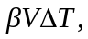 and the change in volume due to the pressure increase is 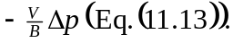 Setting the net change equal to zero, 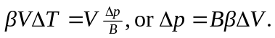 b) From the above,

